Justin L. Beeden

@jbeeden

Documentation v1.1

December 5, 2013

Exchange 2013 DAG node server maintenance scripts.

For proper Exchange 2013 DAG node maintenance

Contents

Get2013DagServerMaintenance.ps1 v1.3 2

Start2013DagServerMaintenance.ps1 v2.0 3

QueueTargetFQDN validation 3

DAG File Share Witness check 4

Maintenance Mode 5

Transport Queue Check 5

Hosting Active Database Copies Check 6

Stop2013DagServerMaintenance.ps1 v1.2 7

Exchange 2013 DAG node server maintenance scripts.

# Get2013DagServerMaintenance.ps1 v1.3

The Get2013DagServerMaintenance.ps1 script has no logic built in, it should just be used to pull information and display it on the screen to manually check server node settings.

It has one parameter, which is the server to check, it can be entered in line with the script or the script will prompt you for the server name if the script is run with no parameters.

Below is what is returned when a server is **NOT** in maintenance mode:

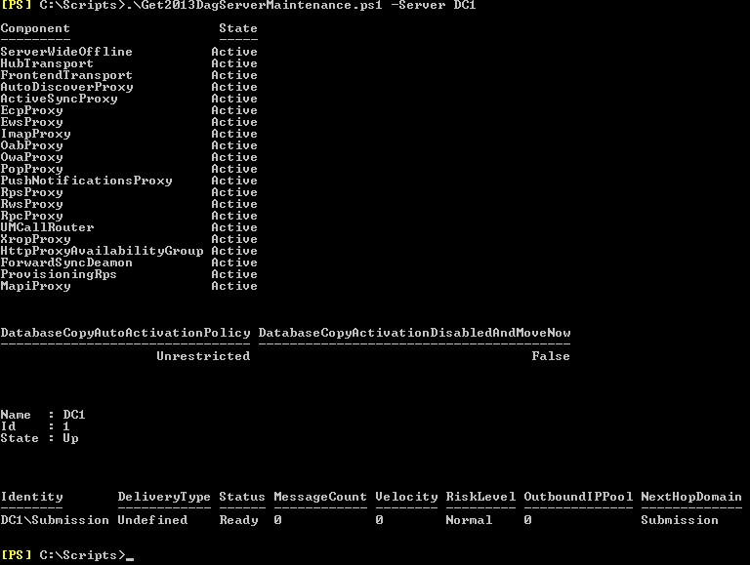

Above notice the server name entered in line with the script. Also note all listed component states are active, DatabaseCopyAutoActivationPolicy is unrestricted, DatabaseCopyActivationDisabledAndMoveNow is false, and the cluster node is up. Also, there just happen to be zero messages in the transport queue even though the queues are functioning.

Below is what is returned when a server **IS** in maintenance mode:

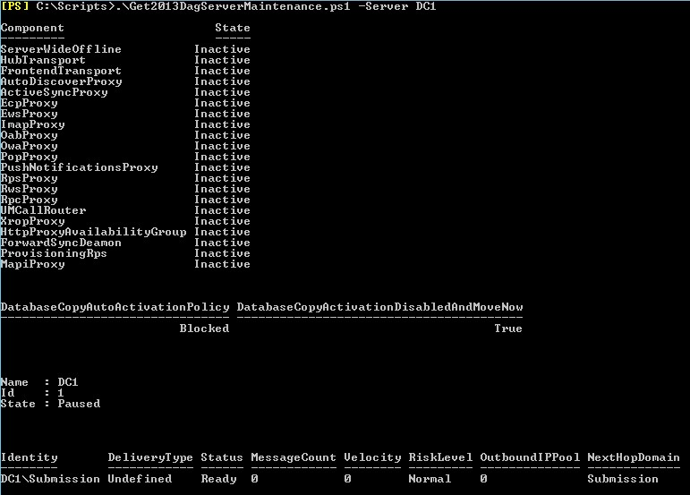

Above, note all component states listed are inactive, DatabaseCopyAutoActivationPolicy is blocked, DatabaseCopyActivationDisabledAndMoveNow is true, the cluster node is paused, and there are zero messages in the transport queue.

Again this script just pulls information to **MANUALLY VERIFY** whether a server is fully in maintenance mode or not, it **DOES NOT** have any logic built in.

This script can be run at any time and should be used before and after starting maintenance mode on a server and also before and after stopping maintenance mode on a server.

# Start2013DagServerMaintenance.ps1 v2.0

The Start2013DagServerMaintenance.ps1 script has built in logic to verify a few prerequisites before it actually starts the process of placing an Exchange Server 2013 DAG node into maintenance mode.

It has two mandatory parameters, the first is the server you want to place into maintenance mode and the second is the FQDN of the server where you would like the active transport queues moved to. They can also be entered in line with the script or the user will be prompted for them after running the script.

## QueueTargetFQDN validation

After running the script with the two parameters, the first built in logic is to check whether the second parameter, the QueueTargetFQDN, is actually a FQDN and not just a hostname. If just a hostname was specified the script will attempt to resolve the hostname to a FQDN. If it can be resolved the script will continue, if it cannot be resolved the script will throw an error and quit.

Below, just a hostname of BOBO was entered. This hostname was not resolved in DNS so the script exits.

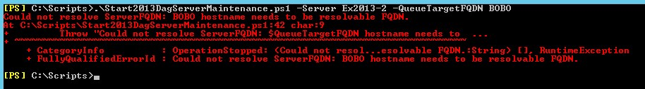

If BOBO was a valid hostname and resolvable in DNS the script would have continued normally.

## DAG File Share Witness check

The next validation step for the script is to test whether the DAG is configured to use a File Share Witness and if so, if it is seen as functioning from Exchange. A DAG will use a File Share Witness when it has an even number of nodes, it is used to maintain Quorum within the DAG cluster. If the FSW is needed and not functioning, placing a DAG node into maintenance mode and performing maintenance could make the DAG lose Quorum. If a DAG loses Quorum EVERY database in the DAG will dismount.

The script will check that either the Primary or Alternate FSW that is configured for the server’s DAG is reported as operating normally from Exchange. If it is not found operational the script will exit with the below error.

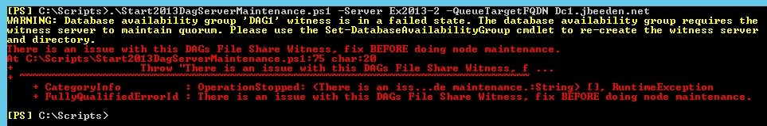

If either the Primary or Alternate FSW that is configured for the server’s DAG is reported as operating normally from Exchange, the script will start to place the server into maintenance mode.

## Maintenance Mode

If the above prerequisite checks all pass, the script will start placing the server into maintenance mode. The actual steps will not be mentioned but can be found at the following URL:

http://technet.microsoft.com/en-us/library/dd298065%28v=exchg.150%29.aspx#Pm

The script output will look something like the below screen shot.

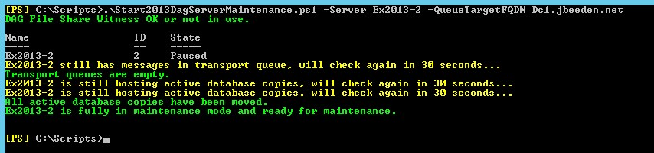

The script also supports verbose mode. Verbose mode will show additional information about exactly what the script is doing and when, as seen in the below screen shot.

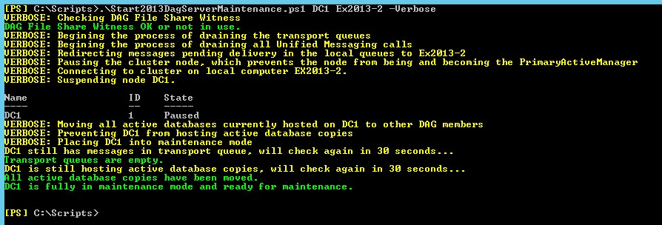

You can also note in the above screen shot that the server names were, first not entered with the parameter names, and second, the second server should be a FQDN but it is only a hostname. The script’s parameters are positional, so you do not need to enter the parameter names. You just need to enter the server going into maintenance mode first, then the target server for the transport queues second. The scripts built in logic took care of the hostname since it was resolved in DNS.

## Transport Queue Check

Before the script completes, two additional steps are taken to make sure the server has been fully placed into maintenance mode. The first is whether the active transport queues have been successfully emptied or moved to the QueueTargetFQDN server.

In both of the above screenshots you can see the warning in yellow that the server *“<Server>* still has messages in transport queue, will check again in 30 seconds…” The script will continue to check every 30 seconds until all local transport queues have zero messages. This could take longer than the above screenshots due to mail volume on the server being placed into maintenance mode. When zero messages are in the transport queues the script will report “Transport queues are empty” and continue. As seen in above screen shots.

## Hosting Active Database Copies Check

The last step performed by the script before fully placing the server into maintenance mode will check whether the node is still hosting active database copies.



In the above screen shot, you can see after the “Transport queues are reported as empty”, the script will warn “*<Server>* is still hosting active database copies, will check again in 30 seconds…” The script will continue to check every 30 seconds until all local active database copies have been activated on another node in the DAG. This could take longer than the above screenshot due to the number and or size of active database copies that the server being placed into maintenance mode is hosting. When zero active database copies are hosted on the server the script will report “All active database copies have been moved.” After this, the server is now fully in maintenance mode and the script reports *“<Server>* is fully in maintenance mode and ready for maintenance.” As seen in above screen shot.

*It is highly recommended to once again run the Get2013DagServerMaintenance.ps1 script to manually confirm the changes have been applied.*

# Stop2013DagServerMaintenance.ps1 v1.2

After all maintenance has been successfully completed on the node, the node must now be brought out of maintenance mode. The Stop2013DagServerMaintenance.ps1 can now be run to stop maintenance mode on a server.

It has one parameter, which is the server to stop maintenance mode on, it can be entered in line with the script or the script will prompt you for the server name if the script is run with no parameters. This script currently does not do any prerequisite checks.

Below is what the script will return using the –Verbose parameter:

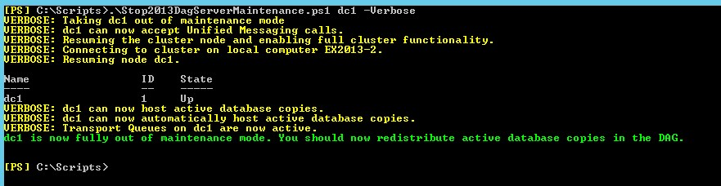

After all the settings that were changed by the Start2013DagServerMaintenance.ps1 script have been reversed, the script will report *“<Server>* is now fully out of maintenance mode. You should now redistribute active database copies in the DAG.”

*Please be aware that taking a server out of maintenance mode WILL NOT activate any database copies on the node, it will just allow the node to mount active database copies.*

*It is highly recommended to once again run the Get2013DagServerMaintenance.ps1 script to manually confirm the changes have been applied.*